**OIL AND NATURAL GAS CORPORATION SUMMER INTERNSHIP 2020**

**PROJECT REPORT ON**

**FACIES VISUALIZATION**

**AND CLASSIFICATION**

**BY DEEP LEARNING**

**SUBMITTED BY:** ADITYA KOTHARI

**STREAM:** BTECH (CSE)

**COLLEGE:** GRAPHIC ERA UNIVERSITY

**ACKNOWLEDGEMENT**

We have taken efforts in this project. However, it would not have been possible without the kind support and help of many individuals and organizations. I would like to extend my sincere thanks to all of them.

I am highly indebted to *Mr. Pushpendra Singh* for their guidance and constant supervision as well as for providing necessary information regarding the project & also for their support in completing the project.

I would like to express my gratitude towards my parents& member of Oil and Natural Gas Corporation for their kind co-operation and encouragement which help me in completion of this project.

I would like to express my special gratitude and thanks to industry persons for giving me such attention and time.

My thanks and appreciation also goes to my colleague, *Mr. Tanmay Gupta*, in developing the project and people who have willingly helped me out with their abilities.

**BACKGROUND**

In geology, a **Facies** is a body of a rock with specified characteristics, which can be any observable attribute of rocks (such as their overall appearance, composition or condition of formation), and the changes that may occur in those attributes over a geographic area. It is the sum total characteristics of a rock including its chemical, physical, and biological features that distinguishes it from adjacent rock.

**Facies classification** refers to assigning a rock type or a class to specific rock examples on the basis of measured rock properties. Classification of rocks is fundamental to geology and a variety of useful classification schemes may be employed, depending upon the circumstances. Rocks of the Council Grove Group fall into the large category of sedimentary rocks that, in this project, is subdivided intothe nine discrete facies (classes of rocks)as follows:

1. Nonmarine sandstone ( SS )
2. Nonmarine coarse siltstone ( CSiS )
3. Nonmarine fine siltstone ( FSiS )
4. Marine siltstone and shale ( SiSh )
5. Mudstone (limestone) ( MS )
6. Wackestone (limestone) ( WS )
7. Dolomite ( D )
8. Packstone-grainstone (limestone) ( PS )
9. Phylloid-algal bafflestone (limestone) ( BS )

These facies aren't discrete, and gradually blend into one another. Some have neighboring facies that are rather close. Mislabeling within these neighboring facies can be expected to occur.

**DATASET**

Facies and rocks in general have a large number of physical and chemical properties that can be used for classification. In oil and gas wells the most readily available properties related to the rocks encountered are measurements made by petro physical tools lowered into the eight-inch wellbore after a well is drilled. Digital information is recorded at half-foot increments from a variety of devices that measure a number of physical properties (porosity, natural gamma radiation, resistivity, photoelectric effect). These properties, their combinations or derivatives, are possible elements of feature vectors spaced at a half-foot increment in a wellbore. Predictor variables include five from wireline log measurements and two geologic constraining variables that are derived from geologic knowledge.The seven predictor variables are:

* Five wire line log curves include gammaray (GR), [resistivity logging](http://petrowiki.org/Resistivity_and_spontaneous_%28SP%29_logging) (ILD_log10), [photoelectric effect](http://www.glossary.oilfield.slb.com/en/Terms/p/photoelectric_effect.aspx) (PE), [neutron-density porosity difference and average neutron-density porosity](http://petrowiki.org/Neutron_porosity_logs) (Delta PHI and PHIND). Note, some wells do not have PE.
* Two geologic constraining variables: Nonmarine-marine indicator (NM_M) and relative position (RELPOS)

This rock facies classification problem is part of a geologic modeling project of the Council Grove Group that is being undertaken at the Kansas Geological Survey (KGS). The Council Grove is a rock stratigraphic interval that produces gas in the Panoma Gas Field in southwest Kansas. The Panoma Council Grove Field is predominantly a carbonate gas reservoir encompassing 2700 square miles in Southwestern Kansas. This dataset is from nine wells (with 4062 examples). It is divided into two parts as:

1. *Training data* (3232 examples) - It consist of a set of seven predictor variables and a rock facies (class) for each example vector. This data further undergoes an 80-20% split into actual training data and validation/test data.
2. *New unseen data* (830 examples from two wells) – This data belongs to two wells which the model has not seen before and have the same seven predictor variables in the feature vector but not the facies (class) to which they belong to.

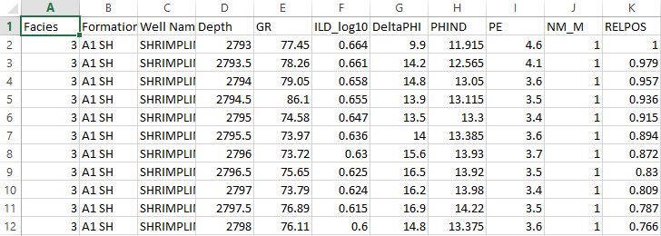Here’s how our dataset looks like:

The first column labelled ‘Facies’ is our target variable that the model needs to learn to predict and rest all the columns are the input features. Each row of the dataset acts as a feature vector.

**VISUALIZATION**

The visualization step is performed first where we take the insight of data. We get to learn about the different facies and in what number they are present in the dataset. Based on this step we take the intuition that which model to choose so that we can classify different facies and what preprocessing on the dataset would be needed for better results.

Here is the graph of number of different facies.

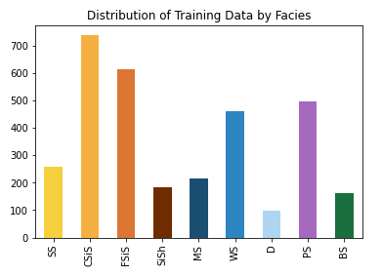

**MODEL ARCHITECTURE**

The Deep Learning architecture that we have used in this project is an Artificial Neural Network.An **Artificial neural network** (**ANN**) or **connectionist system** is a computing system vaguely inspired by the biological neural networks that constitute animal brains.Such systems "learn" to perform tasks by considering examples, generally without being programmed with task-specific rules.The original goal of the ANN approach was to solve problems in the same way that a human brain would. But over time, attention moved to performing specific tasks, leading to deviations from biology, like computer vision, speech recognition, machine translation, social network filtering, playing board and video games, medical diagnosis, and even in activities that have traditionally been considered as reserved to humans, like painting. Due to its excellent performance over other machine learning algorithms an ANN is used for such wide range of applications and that is why we also built and trained an ANN for our classification task.

Our model’s architecture is as follows:

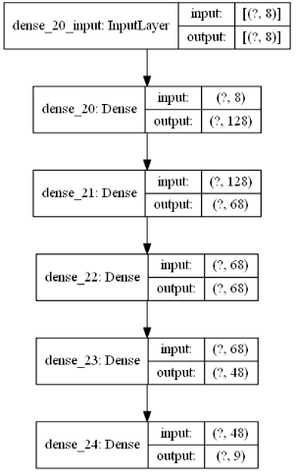

**TRAINING AND TESTING**

We trained our model for 80 epochs with 80% (2585 examples) training data and 20% (647 examples) as validation data to tune the hyperparameters and to reduce the overfitting. At the end of 80 epochs we get:

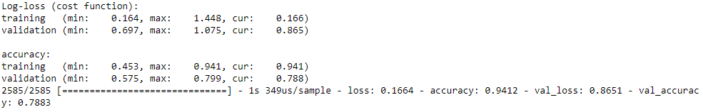

On test data, our model gave the following results:

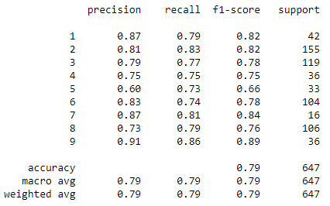

Calculating precision, recall and F1-score is the standard way to evaluate our model’s performance.

**RESULTS**

The accuracy of the model is found to be nearly 79% on our test data. However since these facies aren't discrete, and they gradually blend into one another so some have neighboring facies that are rather close and mislabeling within these neighboring facies is expected to occur even by humans, due to which the accuracy is evaluated as 79%. But if we consider the prediction to be correct even if it is not the exact label but one of its close neighbors then the accuracy is evaluated as 96% which is very good.

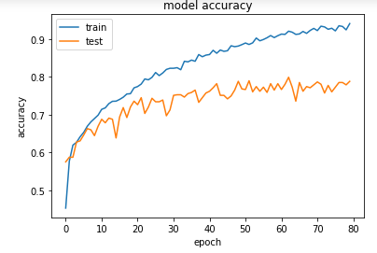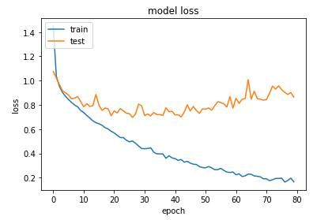

Accuracy vs Iterations graph Loss vs Iterations graph

**FACIES LOG-PLOT FOR NEW DATA**

Now after the model is created, we applied the model on the new set of data belonging to two wells that had not been seen by the model yet thus it gives our model an oppurtunity to work on new real world data and its performance can be shown with the help og facies log plots as below :

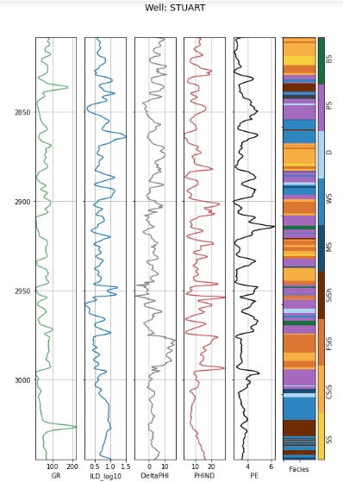

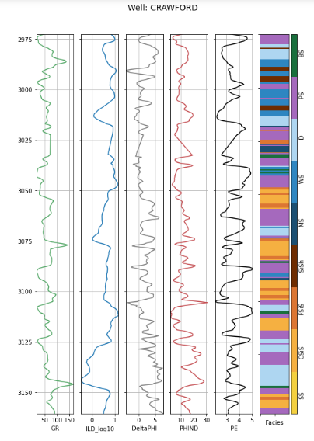

**REFRENCES**

Amato del Monte, A., 2015. Seismic Petrophysics: Part 1, *The Leading Edge*, 34 (4). [doi:10.1190/tle34040440.1](http://dx.doi.org/10.1190/tle34040440.1)

Bohling, G. C., and M. K. Dubois, 2003. An Integrated Application of Neural Network and Markov Chain Techniques to Prediction of Lithofacies from Well Logs, *KGS Open-File Report* 2003-50, 6 pp. [pdf](http://www.kgs.ku.edu/PRS/publication/2003/ofr2003-50.pdf)

Dubois, M. K., G. C. Bohling, and S. Chakrabarti, 2007, Comparison of four approaches to a rock facies classification problem, *Computers & Geosciences*, 33 (5), 599-617 pp. [doi:10.1016/j.cageo.2006.08.011](http://dx.doi.org/10.1016/j.cageo.2006.08.011)